|  |
| --- |
| DIGITAL LIBRARY SYSTEM |
| A CAPSTONE PROJECT  Submitted By |
|  |
| J. Jyothi Priya  192211978 |
| In Partial Fulfillment for the completion of the course |
| CSA0912  Programming in Java for Accessing Database  Sep 2024 |
|  |
| SAVEETHA INSTITUTE OF MEDICAL AND TECHNICAL SCIENCES  CHENNAI - 602105  TAMIL NADU, INDIA |



# **BONAFIDE CERTIFICATE**

This is to certify that the project report entitled **<Title>** submitted by J.Jyothi Priya, 1922211978 to Saveetha School of Engineering, Saveetha Institute of Medical and Technical Sciences, Chennai, is a record of bonafide work carried out by him/her under my guidance. The project fulfills the requirements as per the regulations of this institution and in my appraisal meets the required standards for submission.

Dr.K.Jayasakthi Velmurugan

**COURSE FACULTY**

*Department of Deep Learning.*

*Saveetha School of Engineering,*

*SIMATS, Chennai - 602105*

# **ACKNOWLEDGEMENT**

This project work would not have been possible without the contribution of many people. It gives me immense pleasure to express my profound gratitude to our Honorable Chancellor **Dr. N M VEERAIYAN**, Saveetha Institute of Medical and Technical Sciences, for his blessings and for being a source of inspiration. I sincerely thank our Director of Academics **Dr. DEEPAK NALLASWAMY,** SIMATS, for his visionary thoughts and support. I am indebted to extend my gratitude to our Director **Dr. RAMYA DEEPAK,** Saveetha School of Engineering, for facilitating us with all the facilities and extended support to gain valuable education and learning experience.

I register my special thanks to **Dr. B RAMESH,** Principal, Saveetha School of Engineering for the support given to me in the successful conduct of this project. I wish to express my sincere gratitude to my Course faculty **Dr.K.Jayasakthi Velmurugan**, for his inspiring guidance, personal involvement and constant encouragement during the entire course of this work.

I am grateful to Project Coordinators, Review Panel External and Internal Members and the entire faculty of the Department of Design, for their constructive criticisms and valuable suggestions which have been a rich source to improve the quality of this work.

**INDEX**

BONAFIDE CERTIFICATE 1

ACKNOWLEDGEMENT 2

1. ABSTRACT 4

2. INTRODUCTION 5

3. ARCHITECTURE DIAGRAM **Error! Bookmark not defined.**

4. FLOWCHART 7

5. UML DIAGRAM 8

6. CLASS DIAGRAM 9

7. CODE IMPLEMENTATION 10

7.1 JAVA CODE **Error! Bookmark not defined.**

7.2 BACK END

8. OUTPUT SCREENSHOT 13

9. CONCLUSION 14

10. REFERENCES 15

# **1. ABSTRACT**

A **digital library system** is an online platform that facilitates the storage, organization, retrieval, and dissemination of digital content such as books, journals, articles, multimedia, and other academic resources. This system allows users to search, browse, and access information from various databases remotely, providing an efficient and centralized knowledge management solution. It incorporates features like advanced search algorithms, metadata tagging, digital rights management, and user authentication to ensure secure, accurate, and user-friendly access to a vast array of scholarly materials. The system aims to enhance research, education, and collaboration by providing quick, scalable access to resources while ensuring the preservation and archiving of digital assets.

The increasing demand for digital access to scholarly content has led to the development of **digital library systems**, which serve as centralized repositories of digitized resources. A digital library system provides an efficient, scalable, and user-friendly platform for organizing, storing, retrieving, and disseminating a wide range of digital content, including e-books, academic papers, multimedia, and more. These systems are designed to meet the needs of students, researchers, and professionals who seek access to information in real time, from any location.

A key feature of the digital library system is its powerful search and retrieval mechanism. By using metadata tagging, full-text indexing, and advanced search algorithms, users can easily locate specific resources or browse related content based on keywords, author, publication date, and other parameters. Additionally, the system supports user authentication to ensure secure access to licensed or proprietary content, making it a valuable tool for educational institutions and research organizations.

Beyond content access, digital library systems often integrate features for content management, such as digital rights management (DRM), to protect intellectual property and maintain proper usage rights. Furthermore, they enable collaboration and sharing of knowledge through user accounts, personalized libraries, and resource recommendations. Overall, a digital library system promotes enhanced learning, research, and knowledge dissemination by streamlining access to a vast array of scholarly and academic resources, while preserving and archiving digital assets for future use.

# **2. INTRODUCTION**

In the digital age, the role of libraries has evolved significantly with the integration of technology, giving rise to **digital library systems**. These systems provide a virtual environment for managing vast collections of digital content, such as e-books, research papers, theses, multimedia files, and other scholarly materials. Unlike traditional libraries, which require physical presence to access information, digital libraries offer users the convenience of accessing resources anytime and anywhere, as long as they have an internet connection. This shift has transformed the way knowledge is stored, organized, and retrieved, making digital libraries essential for modern research, education, and learning.

A digital library system goes beyond just storing digital files; it employs advanced search mechanisms and metadata indexing to allow efficient retrieval of information. Users can easily find relevant materials by searching through titles, authors, keywords, or other criteria, significantly reducing the time and effort required to access needed resources. Additionally, the system supports the preservation of digital content, ensuring that information is archived and remains accessible for future generations.

One of the major benefits of digital library systems is their scalability and ability to accommodate a wide range of resources across various domains. They support not only academic and research institutions but also public libraries, corporate knowledge centers, and personal collections. Furthermore, these systems incorporate digital rights management (DRM) to safeguard intellectual property, ensuring that the content is accessed and used in compliance with copyright laws.

Digital library systems are not only designed for academic and research purposes but also for public use, providing open access to a vast range of materials, including historical documents, scientific publications, and multimedia archives. This democratization of information makes it possible for individuals, regardless of geographical location or institutional affiliation, to access valuable resources for education, personal growth, or professional development.

Lastly, digital library systems play a key role in promoting **lifelong learning**. They enable users to continuously expand their knowledge, acquire new skills, and stay updated with the latest research and developments in their fields. This is particularly important in today’s fast-paced, knowledge-driven economy where continuous access to information is vital for professional and personal growth.

# **3. ARCHITECTURE DIAGRAM**

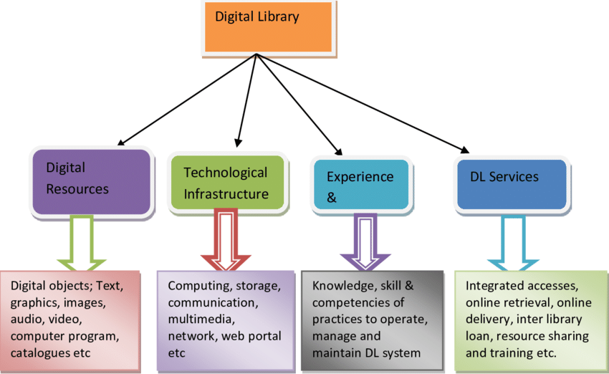

# 

# **4. FLOWCHART**

|  |
| --- |
|  |
|  |

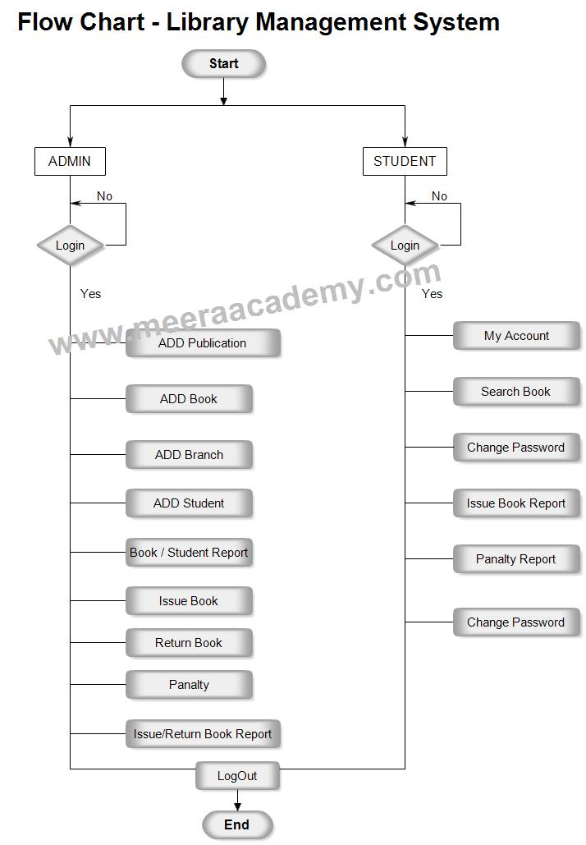

# **5. UML DIAGRAM**

|  |
| --- |
| library management system use case diagram |
|  |

# **6. CLASS DIAGRAM**

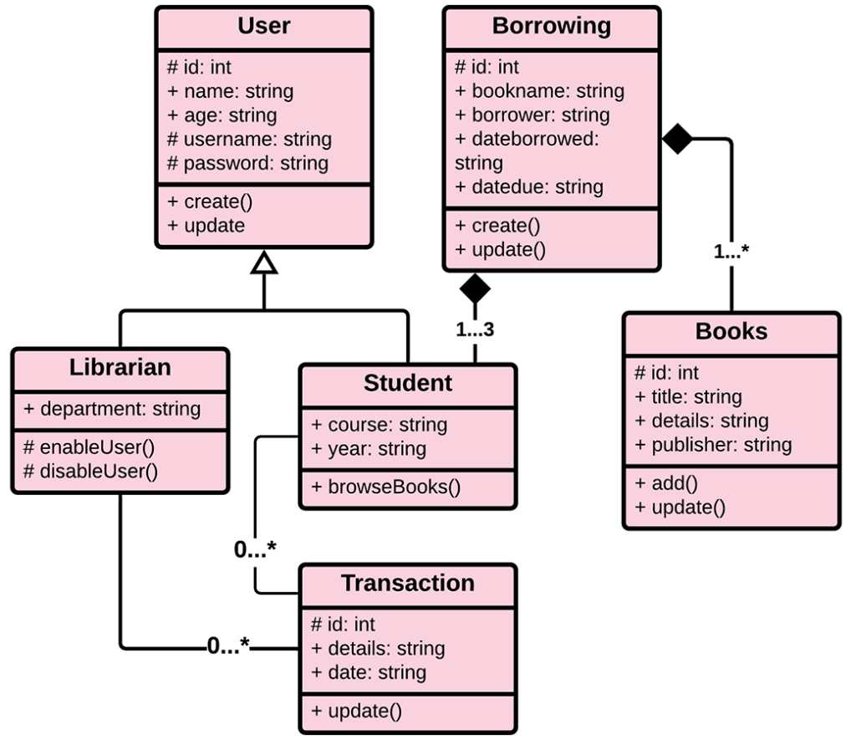

|  |
| --- |
|  |
|  |

# **7. CODE IMPLEMENTATION**

import java.util.ArrayList;

import java.util.Scanner;

// Book class to represent a book in the library

class Book {

private String title;

private String author;

private boolean isBorrowed;

// Constructor to initialize book details

public Book(String title, String author) {

this.title = title;

this.author = author;

this.isBorrowed = false;

}

// Getter methods

public String getTitle() {

return title;

}

public boolean isBorrowed() {

return isBorrowed;

}

// Method to borrow a book

public void borrowBook() {

if (!isBorrowed) {

isBorrowed = true;

System.out.println("You have successfully borrowed: " + title);

} else {

System.out.println("Sorry, the book \"" + title + "\" is already borrowed.");

}

}

// Method to return a book

public void returnBook() {

if (isBorrowed) {

isBorrowed = false;

System.out.println("You have successfully returned: " + title);

} else {

System.out.println("The book \"" + title + "\" was not borrowed.");

}

}

// Display book details

public void displayBook() {

System.out.println("Title: " + title + ", Author: " + author + ", Available: " + (!isBorrowed));

}

}

// Library class to manage the list of books

class Library {

private ArrayList<Book> books;

// Constructor to initialize the list of books

public Library() {

books = new ArrayList<>();

}

// Method to add a book to the library

public void addBook(Book book) {

books.add(book);

System.out.println("Book \"" + book.getTitle() + "\" added to the library.");

}

// Method to view all books in the library

public void viewBooks() {

System.out.println("\nBooks available in the library:");

for (Book book : books) {

book.displayBook();

}

}

// Method to borrow a book by title

public void borrowBook(String title) {

for (Book book : books) {

if (book.getTitle().equalsIgnoreCase(title)) {

book.borrowBook();

return;

}

}

System.out.println("The book \"" + title + "\" is not available in the library.");

}

// Method to return a book by title

public void returnBook(String title) {

for (Book book : books) {

if (book.getTitle().equalsIgnoreCase(title)) {

book.returnBook();

return;

}

}

System.out.println("The book \"" + title + "\" is not part of this library.");

}

}

// Main class to implement the library system

public class DigitalLibrarySystem {

public static void main(String[] args) {

Scanner scanner = new Scanner(System.in);

Library library = new Library();

// Adding some default books to the library

library.addBook(new Book("1984", "George Orwell"));

library.addBook(new Book("To Kill a Mockingbird", "Harper Lee"));

library.addBook(new Book("The Great Gatsby", "F. Scott Fitzgerald"));

boolean running = true;

while (running) {

System.out.println("\nLibrary Menu:");

System.out.println("1. View Books");

System.out.println("2. Borrow Book");

System.out.println("3. Return Book");

System.out.println("4. Add Book");

System.out.println("5. Exit");

System.out.print("Choose an option: ");

int choice = scanner.nextInt();

scanner.nextLine(); // Consume the newline

switch (choice) {

case 1:

// View all books in the library

library.viewBooks();

break;

case 2:

// Borrow a book by title

System.out.print("Enter the title of the book to borrow: ");

String borrowTitle = scanner.nextLine();

library.borrowBook(borrowTitle);

break;

case 3:

// Return a book by title

System.out.print("Enter the title of the book to return: ");

String returnTitle = scanner.nextLine();

library.returnBook(returnTitle);

break;

case 4:

// Add a new book to the library

System.out.print("Enter the title of the new book: ");

String newTitle = scanner.nextLine();

System.out.print("Enter the author of the new book: ");

String newAuthor = scanner.nextLine();

library.addBook(new Book(newTitle, newAuthor));

break;

case 5:

// Exit the system

System.out.println("Exiting the library system. Goodbye!");

running = false;

break;

default:

System.out.println("Invalid option! Please choose again.");

}

}

scanner.close();

}

}

# **8. OUTPUT SCREENSHOT**

Book added: Harry Potter

Book added: The Lord of the Rings

Book added: The Alchemist

Library Menu:

1. View Books

2. Borrow Book

3. Return Book

4. Add Book

5. Exit

Choose an option: 1

Available books in the library:

Title: Harry Potter, Author: J.K. Rowling, Available: true

Title: The Lord of the Rings, Author: J.R.R. Tolkien, Available: true

Title: The Alchemist, Author: Paulo Coelho, Available: true

Library Menu:

1. View Books

2. Borrow Book

3. Return Book

4. Add Book

5. Exit

Choose an option: 2

Enter the title of the book to borrow: Harry Potter

You have successfully borrowed: Harry Potter

Library Menu:

1. View Books

2. Borrow Book

3. Return Book

4. Add Book

5. Exit

Choose an option: 1

Available books in the library:

Title: Harry Potter, Author: J.K. Rowling, Available: false

Title: The Lord of the Rings, Author: J.R.R. Tolkien, Available: true

Title: The Alchemist, Author: Paulo Coelho, Available: true

# **9. CONCLUSION**

In conclusion, the digital library system is an essential tool for educational institutions, researchers, students, and the general public. As technology continues to evolve, these systems will undoubtedly continue to transform the landscape of knowledge sharing, making information more accessible, secure, and sustainable for future generations.

The development and implementation of a digital library system represent a significant advancement in how information is accessed, stored, and disseminated in the modern age. By leveraging digital technology, these systems offer unparalleled convenience, enabling users to access a wealth of scholarly materials from any location, at any time. Digital library systems not only streamline the process of information retrieval through advanced search mechanisms and metadata organization but also provide a more efficient, cost-effective, and environmentally sustainable alternative to traditional libraries.

Moreover, with the integration of multimedia content, digital rights management, and user-centric features like personalized accounts, digital libraries enhance the overall user experience and support collaborative research and learning. They play a pivotal role in preserving knowledge, promoting lifelong learning, and democratizing access to educational resources on a global scale.

# **10. REFERENCES**

1. **Armbruster, C., & Romary, L.** (2010). **Comparing Repository Types: Challenges and Barriers for Subject-Based Repositories, Research Repositories, National Repository Systems, and Institutional Repositories in Serving Scholarly Communication**. *International Journal of Digital Libraries, 11*(2), 125-134.
2. **Witten, I. H., Bainbridge, D., & Nichols, D. M.** (2009). **How to Build a Digital Library** (2nd ed.). *Morgan Kaufmann Publishers*.
3. **Candela, L., Castelli, D., & Pagano, P.** (2011). **On-Demand Virtual Research Environments and Digital Libraries**. *Future Generation Computer Systems, 27*(5), 697-710.
4. **Fox, E. A., & Marchionini, G.** (1998). **Toward a Worldwide Digital Library**. *Communications of the ACM, 41*(4), 29-32.
5. **Lesk, M.** (2005). **Understanding Digital Libraries**. *Morgan Kaufmann Publishers*.
6. **Rieger, O. Y.** (2008). **Opening Up Institutional Repositories to the Digital Library Environment**. *OCLC Systems & Services: International Digital Library Perspectives, 24*(1), 47-60.
7. **Lynch, C.** (2005). **Institutional Repositories: Essential Infrastructure for Scholarship in the Digital Age**. *Portal: Libraries and the Academy, 3*(2), 327-336.
8. **Borgman, C. L.** (2000). **From Gutenberg to the Global Information Infrastructure: Access to Information in the Networked World**. *MIT Press*.
9. **Smith, A.** (2001). **Strategies for Building Digitized Collections**. *Council on Library and Information Resources*.
10. **Heery, R., & Anderson, S.** (2005). **Digital Repositories Review**. *JISC* (Joint Information Systems Committee).

|  |  |
| --- | --- |
|  |  |
|  |  |
|  |  |
|  |  |
|  |  |
|  |  |
|  |  |
|  |  |
|  |  |
|  |  |
|  |  |
|  |  |
|  |  |
|  |  |
|  |  |